**Batch: A-3 Roll No.: 16010122104**

**Experiment / assignment / tutorial No. 7**

**Grade: AA / AB / BB / BC / CC / CD /DD**

**Signature of the Staff In-charge with date**

**Experiment No.:7**

|  |
| --- |
| **TITLE:** Building and configuring simple topology using Network tool - CISCO PACKET TRACER. |

**______________________________________________________________________________**

**AIM:** To build and configure VLAN (Virtual LAN) using CISCO Packet Tracer.

Packet Tracer is a network simulation program that allows students to experiment with network behaviour and ask “what if” questions. Packet Tracer provides simulation, visualization, and authoring, assessment, and collaboration capabilities and facilitates the teaching and learning of complex technology concepts.

**_____________________________________________________________________________**

**Expected Outcome of Experiment:**

**CO1:**  Explain the fundamentals of the data communication networks, reference models,

topologies, physical media, devices, simulators and identify their use in day-to-day networks.

**CO3:** Demonstrate various network layer protocols and network design using IP addressing

concepts.

**_______________________________________________________________**

**Books/ Journals/ Websites referred:**

1. <http://www.google.com>
2. A. S. Tanenbaum, “Computer Networks”, Pearson Education, Fourth Edition
3. B. A. Forouzan, “Data Communications and Networking”, TMH, Fourth Edition
4. [CISCO PACKET TRACER 6.0.1 and Higher version (free download)](https://mega.co.nz/#!q4p0wS7Z!J9jkMwXzZSO4zP1kZX632VFYyxNzwPUhvx8f8Ejyen0 (53.3 MB))

**Pre-Lab/ Prior Concepts: Virtual LAN**

A virtual local area network (VLAN) is a LAN which is not configured by physical wiring but it is configured by software. A VLAN is logical group of network devices that appear to be on same LAN despite their geographical distribution. A VLAN is implemented so that network administrators can connect a group of host in the same domain inspite of their physical location to achieve scalability and improve security features.

To subdivide a network into virtual LANs, one configures a network switch or router. Simpler network devices can partition only per physical port (if at all) , in which case each VLAN is connected with a dedicated network cable ( and VLAN connectivity is limited by the number of hardware ports available) More sophisticated devices can mark packets through tagging, so that a single interconnect ( trunk) may be used to transport data for multiple VLANs. VLAN can greatly simplify network design and deployment, because VLAN membership can be configured through software.

**______________________________________________________________________________**

**New Concepts to be learned**: Purpose of this lab is to become familiar with building Virtual Network in Packet Tracer. ______________________________________________________________________________

**Stepwise-Procedure:**

1. Creating a simple LAN network using packet tracer:

Step 1: Select 12 PCs from the end devices and one fast ethernet switch (2950/24 ports)

Step 2: Connect PCs and switch via copper cable from the panel. Connection can be verified by appearance of all green dots on the links.

Step 3: For PCs to communicate click on PC0.

* Dialog box for PC0 appears
* Click on desktop applications by packet tracer.
* Go to IP configuration.
* Enter IP address to identify host i.e. PC0 (for example: 192.168.1.1)
* Subnet mask-by default already set one can change it as per his/her specification.

Step 4: Repeat step 3 for PC1

Step 5: Ping the PCs and check their working status.

Step 6: Simple PDU (Protocol Data Unit) to simulate network traffic by sending ICMP PDU to assess the network traffic. View simulation in simulation mode

Step 7: . Configure two VLAN in a switch in 6 verticals.

Step 8. As per design, assign membership of VLAN to port using following command

# switch port access vlan2 or vlan3

Step 9. Check status of VLAN.

**IMPLEMENTATION:** (printout of simulation code)

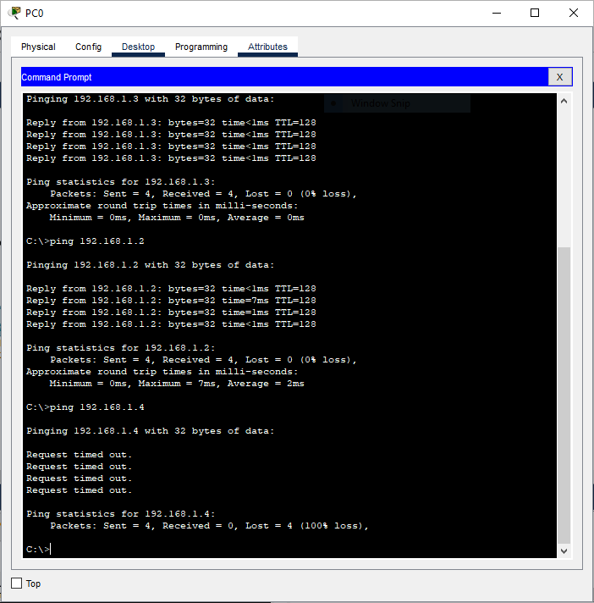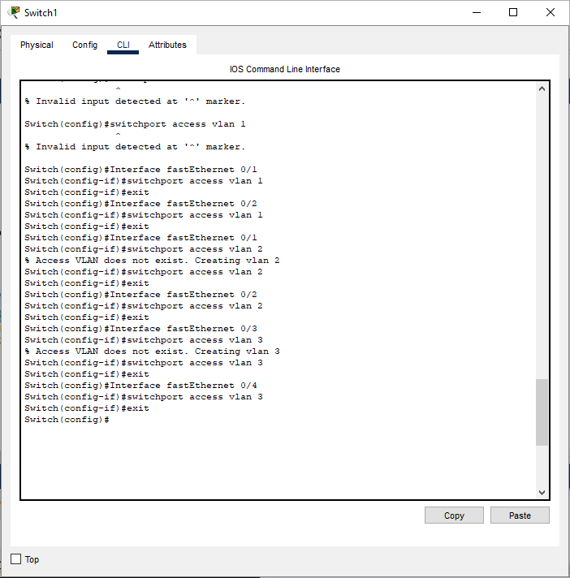

**Network Design**

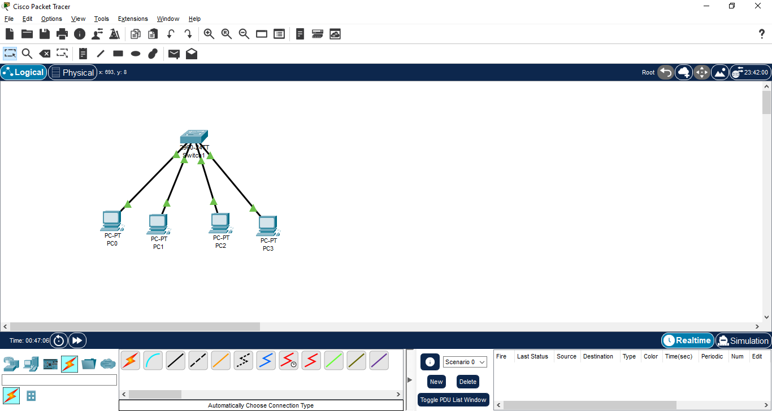

**Observation**

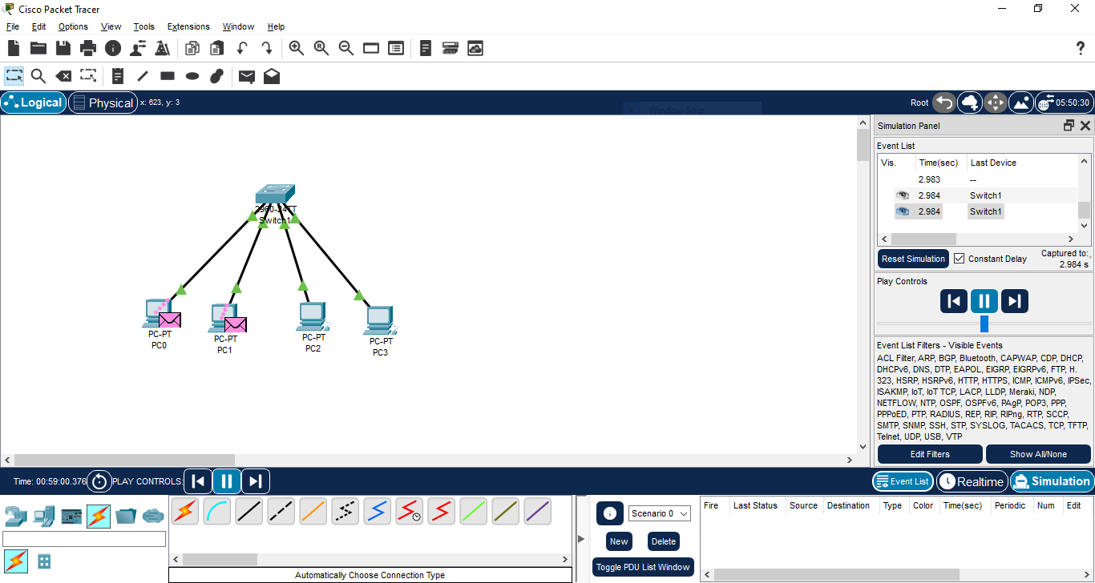

**Post Lab Subjective/Objective type Questions:**

**1.** Describe the concept of Virtual LAN.

**Ans:**

**Concept of Virtual LAN (VLAN):** A **Virtual Local Area Network (VLAN)** is a logical grouping of devices on a network that can communicate with each other as if they were on the same physical network, even if they are physically located on different LAN segments. VLANs allow network administrators to partition a physical network into multiple distinct broadcast domains, thus reducing broadcast traffic, improving security, and enhancing network management. VLANs are configured using network switches, and each VLAN is assigned an ID to distinguish it from others.

2. Compare LAN with VLAN.

**Ans:**

**Comparison between LAN and VLAN:**

| **Feature** | **LAN (Local Area Network)** | **VLAN (Virtual Local Area Network)** |
| --- | --- | --- |
| **Scope** | Physically confined to a specific geographic location, such as a building. | Can span multiple physical LANs but is logically grouped. |
| **Broadcast Domain** | All devices in a LAN share the same broadcast domain. | Each VLAN creates a separate broadcast domain. |
| **Flexibility** | Limited to physical connections and layout. | Offers flexibility in grouping devices regardless of physical location. |
| **Security** | All devices can communicate if they're on the same network. | Devices in different VLANs cannot communicate without a router, improving security. |
| **Configuration** | Configured based on physical layout (cabling). | Configured virtually on switches, independent of physical layout. |
| **Traffic Control** | Higher chances of network congestion in large LANs. | Broadcast traffic is limited to each VLAN, reducing congestion. |

3. State the benefits of implementing VLAN**.**

**Ans:**

Benefits of Implementing VLAN:

* Improved Security: By segregating network traffic between different VLANs, you can restrict communication between devices on different VLANs unless specifically allowed, making it harder for unauthorized users to access sensitive data.
* Traffic Management: VLANs reduce broadcast traffic by segmenting the network into smaller broadcast domains, improving overall network performance.
* Simplified Network Management: VLANs enable better control over network traffic, easier network reconfiguration, and logical groupings of devices that can be managed without physically altering the network.
* Efficient Resource Usage: Network resources such as bandwidth can be allocated more efficiently to specific groups of users or devices, depending on their VLAN membership.
* Enhanced Flexibility: Devices can be grouped logically regardless of their physical location, allowing for easier management of departments or teams that are spread across different locations.

**CONCLUSION:** We built and configured VLAN (Virtual LAN) using CISCO Packet Tracer.

**Date: 11/11/2024 Signature of faculty in-charge**